**Report**

**Strain study at Instron (27.11.2023).**

**CHAPTER 1**

**The torque was applied.**

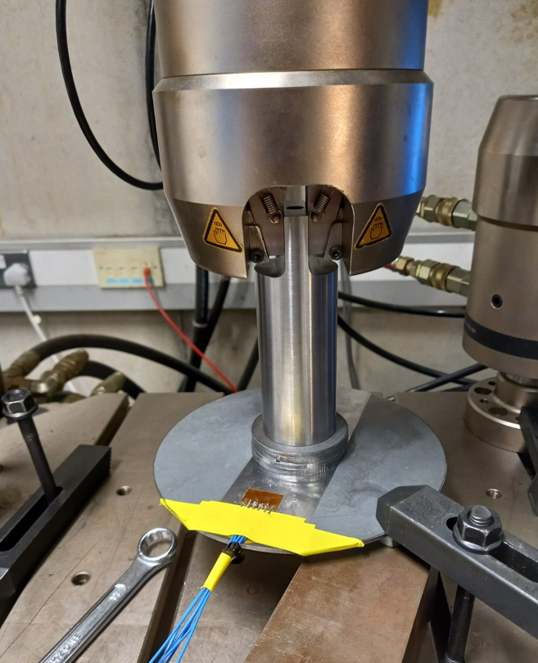

Fig. 1. Experimental set up

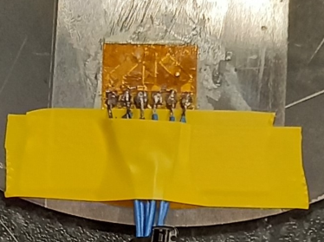

1

2

3

a b

Fig. 2. Strain gauges location: a) Gauge configuration Rosette; b) Rosette settlement

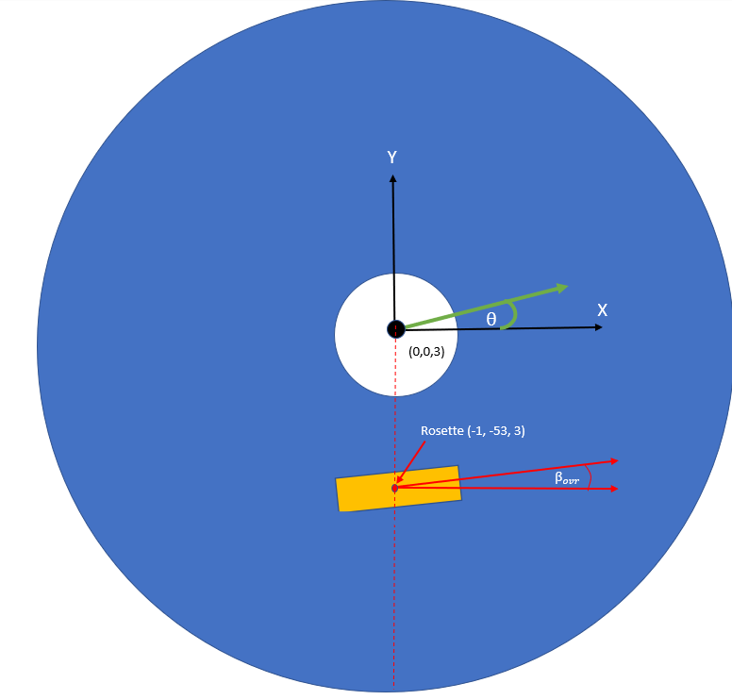

(0,0,3)

Figure 3. Rosette position and angle

Note:

(0,0,0) is located at centre of bottom surface of disc

(-1, -53, 4)

θ

(0,0,3) is located at centre of top surface of disc

= 5.5 degrees

θ is the primary strain angle- this is to be looked at in the coming weeks

Figure 4. Sensor positions and orientations

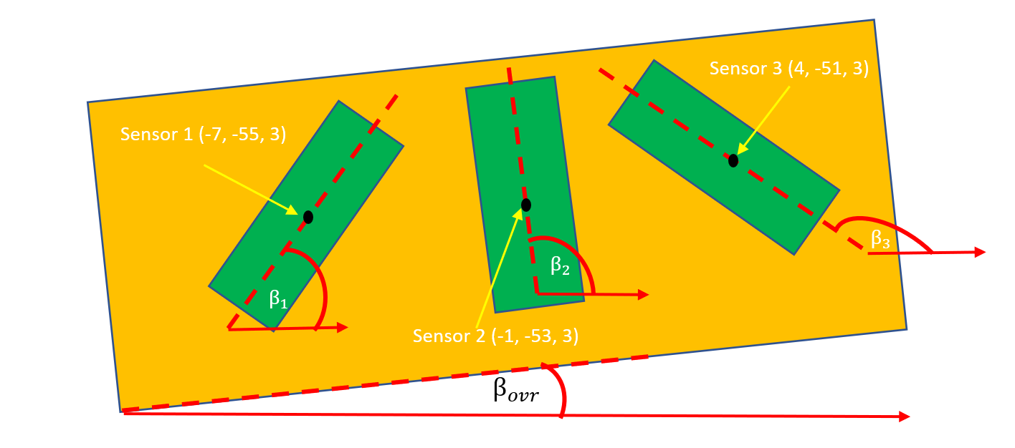Note:

= 50.5 degrees

= 95.5 degrees

= 140.5 degrees

= 5.5 degrees

**Experiment’s conditions**

1. Instron
2. Disk 3 mm
3. Torque was applied clockwise
4. Sensors: sensor 1 gage factor 2.065, sensor 2 gauge factor 2.095; sensor 3 gauge factor 2.065; gage resistance 120 Ohm for each ; Vex source – internal; Vex value 2.5 V (Fig. 3).
5. Torque range 10, 20, 30 Nm
6. Port 0 - Strain 0 (information in DAQ system) - Sensor 1

Port 1 - Strain 1 - Sensor 2

Port 2 – Strain 2 - Sensor 3

1. Data file (column 1 - Sensor 1; column 2 - Sensor 2; column 3 - Sensor 3)
2. LabView 2009
3. ¼ quarter bridge I for each sensor

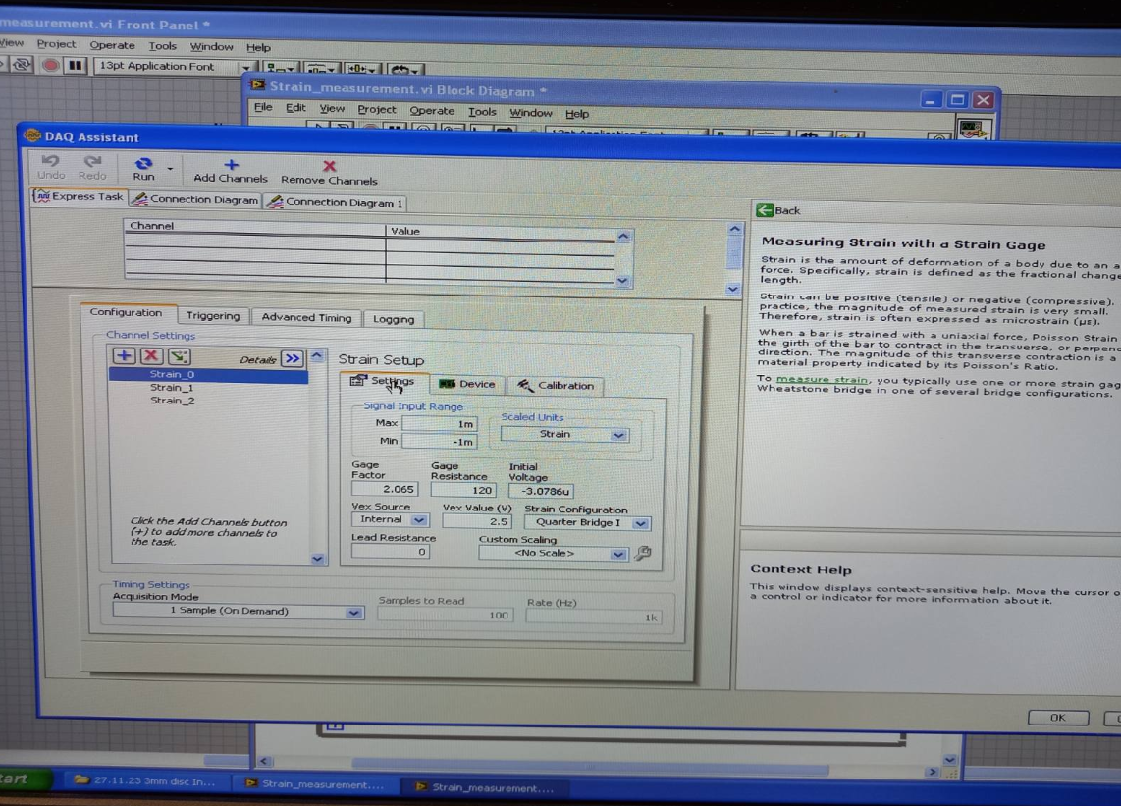

Fig. 5. Screenshot of DAQ Assistant Block

**Chapter 1**

**The disk is mounted on ONE support point – 1 point fixed (Fig. 1, a)**

Fig. 6. Experimental results for Sensor 1

Fig. 7. Experimental results for Sensor 2

Fig. 8. Experimental results for Sensor 3

**Conclusions**

1. With an increase in the applied torque, the level of the information signal increases (taking into account the idle level) for all three sensors.

From 10 Nm to 20 Nm From 10 Nm to 20 Nm

Sensor 1 2 times 2 times

Sensor 2 4.01 times 7.67 times

Sensor 3 1.2 times 4.5 times

2. For all three sensors, the idle level at 30 Nm is different from the idle levels at 10 Nm and 20 Nm. At 10 Nm and 20 Nm the idle signal level does not change.

3. Let's determine the sensitivity of the sensors to changes in the torque value (Table 1 and Table 2).

Sensitivity (S1)=Δ Strain1 / ΔT1

Δ Strain1 – change in Strain value when torque changes from 10 Nm to 20 Nm.

ΔT1 – torque increment. 20 Nm – 10 Nm =10 Nm

Sensitivity (S2)=Δ Strain2 / ΔT2

Δ Strain2 – change in Strain value when torque changes from 10 Nm to 20 Nm.

ΔT2 – torque increment. 20 Nm – 10 Nm =10 Nm.

4. From Table 1 and Table 2 it can be seen that when the torque changes from 10 Nm to 20 Nm, the highest sensitivity is for sensor 2, then 1 and 3. The sensitivity of all three sensors differs slightly: the second sensor is 1.13 times from the first sensor; the second sensor from the third sensor is 1.3 times.

5. When moving from a torque 20 Nm to 30 Nm, the most sensitive sensor is sensor 3, then sensor 2, then sensor 1. Moreover, the sensitivity of sensor 3 is 1.68 times greater, compared to sensor 2 and more by 6.68 times compared to sensor 1.

**6.** Strange behavior is observed when 30N applied to the disc. This is also true when 30N is applied in position 2 in the tests from 28th November. The resting strain is much higher than usual here. The reason for this is not known- possibly Rob didn’t reset the torsion to zero before applying 30N?

7. Strain was much more visible in the 3mm disc than 5mm disc. The increased strain values greatly reduced the effect of noise.

7. It is difficult to determine where the loading phase starts and finishes. Future experiments should have clearly defined resting, loading, constant load, unloading and final resting phases. A 10 second pause should be exercised a) before starting loading b) when the disc is fully loaded c) when the disc is fully unloaded again.

**Table 1**

|  |  |  |  |
| --- | --- | --- | --- |
|  | **Sensor 1** | | |
| **The torque applied** | **10 Nm** | **20 Nm** | **30 Nm** |
| Idle level | 1.82 x10-4 | 1.81 x10-4 | 1.89 x10-4 |
| Work level | 1.84 x10-4 | 1.85 x10-4 | 1.81 x10-4 |
| Difference, numerical value | 2x10-6 | 4x10-6 | 8x10-6 |
|  | **Sensor 2** | | |
| **The torque applied** | **10 Nm** | **20 Nm** | **30 Nm** |
| Idle level | -2.74x10-7 | -3.22x10-7 | -1.06x10-5 |
| Work level | 4.76x10-7 | 2.69x10-6 | 2.31x10-5 |
| Difference, numerical value | 7.5x10-7 | 3.01x10-6 | 2.31x10-5 |
|  | **Sensor 3** | | |
| **The torque applied** | **10 Nm** | **20 Nm** | **30 Nm** |
| Difference, numerical value | 7.9x10-6 | 9.6x10-6 | 43x10-6 |

**Table 2**

|  |  |  |  |  |
| --- | --- | --- | --- | --- |
|  | **Sensor 1** | | | |
| **The torque applied** | 10 | 20 | 20 | 30 |
| Δ Strain | 2x10-6 | | 4x10-6 | |
| Δ Torque, Nm | 10 | | 10 | |
| S | 2x10-7 | | 4x10-7 | |
|  | **Sensor 2** | | | |
| Δ Strain | 2.26x10-6 | | 2.009x10-5 | |
| Δ Torque, Nm | 10 | | 10 | |
| S | 2.26x10-7 | | 2.009x10-6 | |
|  | **Sensor 3** | | | |
| Δ Strain | 1.7x10-6 | | 3.34x10-5 | |
| Δ Torque, Nm | 10 | | 10 | |
| S | 1.7x10-7 | | 3.34x10-6 | |

**CHAPTER 2**

**The axial force was applied.**

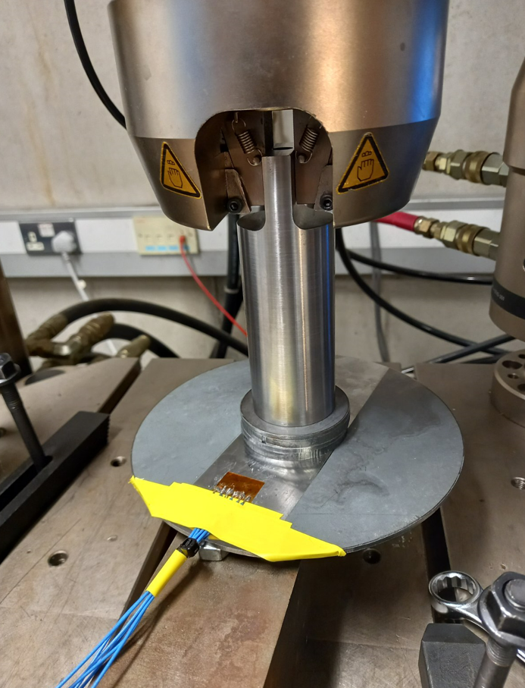

Fig. 9. Experimental set up

1. Instron
2. Disk 3 mm
3. Axial force was applied
4. Sensors: sensor 1 gage factor 2.065, sensor 2 gauge factor 2.095; sensor 3 gauge factor 2.065; gage resistance 120 Ohm for each; Vex source – internal; Vex value 2.5 V (Fig. 3).
5. Force range 5, 10, 20 N
6. Port 0 - Strain 0 (information in DAQ system) - Sensor 1

Port 1 - Strain 1 - Sensor 2

Port 2 – Strain 2 - Sensor 3

1. Data file (column 1 - Sensor 1; column 2 - Sensor 2; column 3 - Sensor 3)
2. LabView 2009
3. ¼ quarter bridge I for each sensor

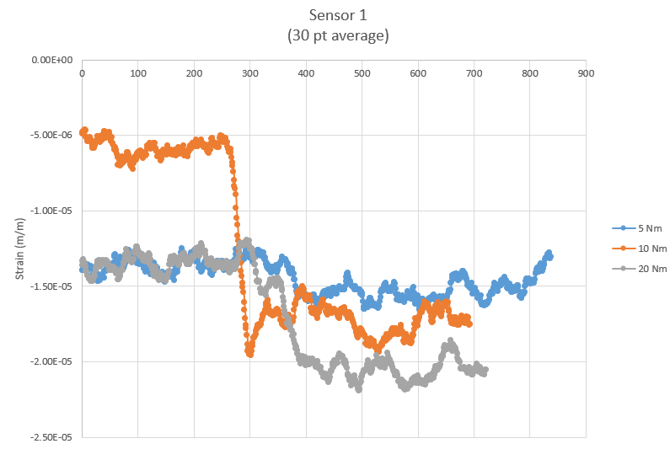

**Figure 10.** Experimental results for sensor 1 under axial loading

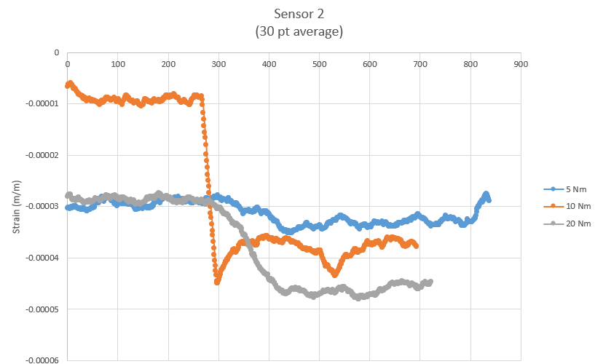

**Figure 11.** Experimental results for sensor 2 under axial loading

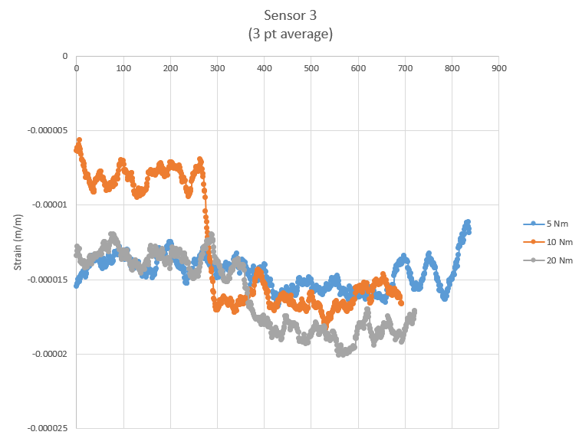

**Figure 12.** Experimental results for sensor 3 under axial loading

Note: The 10 N test was poor- strain in the unloaded state was far away from that of the other 2 loading states. This may have been due to a failure to unload the disc after the previous test.

**Observations**

1. As the applied axial force increases from 5 N to 10 N, the level of the useful signal Strain **increases**

For sensor 1 – 6.73 times

For sensor 2 – 8.09 times

For sensor 3 – 6.67 times

1. As the applied axial force increases from 10 N to 20 N, the level of the useful signal Strain **decreases**

For sensor 1 – 1.63 times

For sensor 2 – 1.69 times

For sensor 3 – 1.60 times

3. **Sensor 2** has the highest sensitivity (Table 3, Table 4)

S1=5.108x10-6 (from 5N to 10 N)

S2=1.194x10-6 (from 10N to 20 N)

**Compared to Sensor 1**

S1=1.95x10-6 (from 5N to 10 N)

S2=4x10-7 (from 10N to 20 N)

**And Sensor 3**

S1=1.36x10-6 (from 5N to 10 N)

S2=3x10-7 (from 10N to 20 N)

**Conclusions:**

1. The strain changed in small increments for these axial loading tests. This meant that noise had a significant impact on the results. To avoid this, a half bridge setup should be used, or higher strain values should be induced in the disc.
2. Future tests should include a return to the unloaded state. This will provide more information about the system behavior. It will also avoid a scenario like above, where the disc was not unloaded before the 10N test, so the resting strain was high.
3. Sensor 2 has the highest sensitivity to axial loading. If we would like to capture axial loading in future experiments, the sensor should be oriented in parallel with the radius it sits on.

**Table 3**

|  |  |  |  |
| --- | --- | --- | --- |
|  | **Sensor 1** | | |
| **The force applied** | **5 N** | **10 N** | **20 N** |
| Idle level | -1.36x10-5 | -5.86x10-6 | -1.35x10-5 |
| Work level | -1.53x10-5 | -1.73x10-5 | -2.05x10-5 |
| Difference, numerical value | -1.7x10-6 | 1.145x10-5 | 7x10-6 |
|  | **Sensor 2** | | |
| **The force applied** | **5 N** | **10 N** | **20 N** |
| Idle level | -2.94x10-5 | -9.06x10-6 | -2.90x10-5 |
| Work level | -3.30x10-5 | -3.82x10-5 | -4.62x10-5 |
| Difference, numerical value | 3.6x10-6 | 2.914x10-5 | 1.72x10-5 |
|  | **Sensor 3** | | |
| **The force applied** | **5 N** | **10 N** | **20 N** |
| Idle level | -1.40x10-5 | -8.07x10-6 | -1.36x10-5 |
| Work level | -1.52x10-5 | -1.63x10-5 | -1.86x10-5 |
| Difference, numerical value | 1.2x10-6 | 8x10-6 | 5x10-6 |

**Table 4**

|  |  |  |  |  |
| --- | --- | --- | --- | --- |
|  | **Sensor 1** | | | |
| **The force applied** | 5 | 10 | 10 | 20 |
| Δ Strain | 9.75x10-6 | | 4.5x10-6 | |
| Δ Force, Nm | 5 | | 10 | |
| S | 1.95x10-6 | | 4x10-7 | |
|  | **Sensor 2** | | | |
| Δ Strain | 2.554x10-5 | | 1.194x10-5 | |
| Δ Force, Nm | 5 | | 10 | |
| S | 5.108x10-6 | | 1.194x10-6 | |
|  | **Sensor 3** | | | |
| Δ Strain | 6.8x10-6 | | 3x10-6 | |
| Δ Force, Nm | 5 | | 10 | |
| S | 1.36x10-6 | | 3x10-7 | |